Student’s Guide to Uploading work on Show My Homework
Homework can be uploaded both in the web browser, or on the Mobile App. Remember, when accessing show my homework that you need to go through RM Unify!
Uploading work on the web browser:
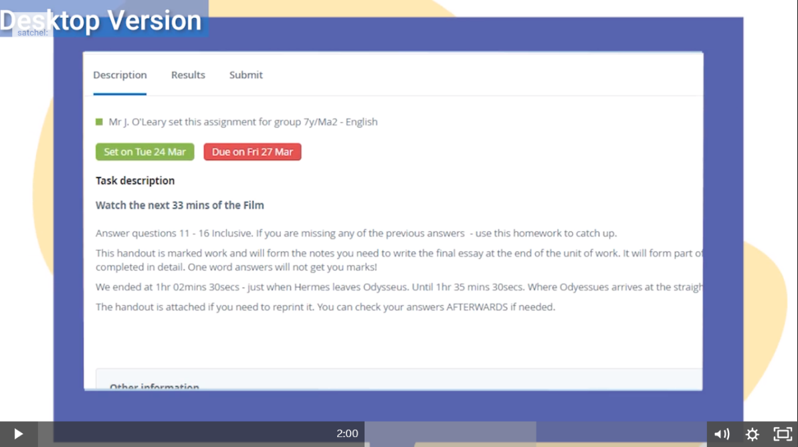
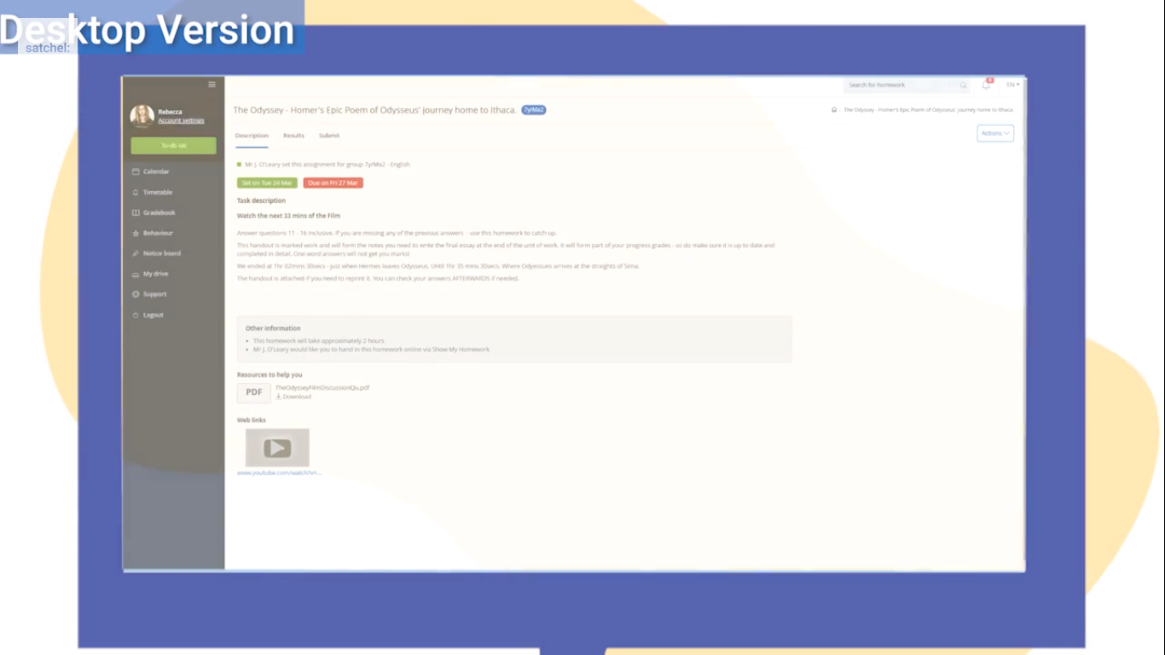
- Find the task that you want to upload work for and click on the submit tab

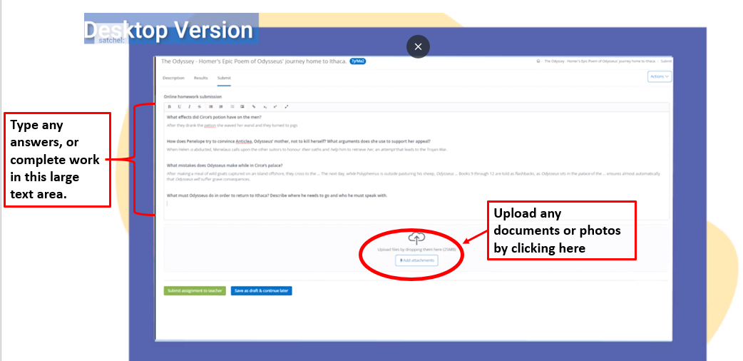
- On this page you will be able to write out answers to any work in the text box, or you can choose to upload any documents or photos by adding attachments (shown)

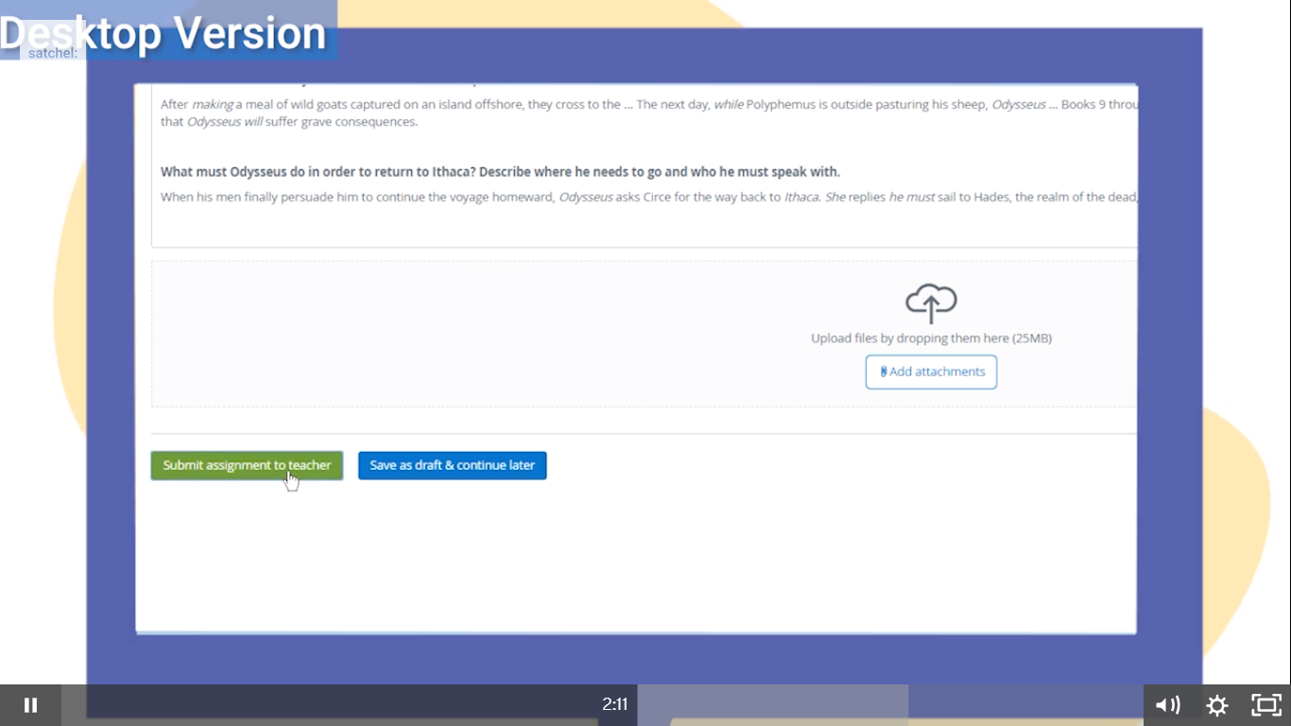
- Once you have finished, and uploaded everything that you want to, click on submit assignment to teacher in the green box.

- Your work has now been submitted and can be viewed by both you and your teacher!

Uploading work to the mobile app:

- Find a piece of homework in your to-do list and press to open the homework task.

- If this is your first time, then the app will give you a tutorial on uploading work. However, if you have forgotten then continue to read this guide.

- You should now see the details for the homework and see any resources that the teacher has provided. To complete the homework on the app simply click where it says message and type in any answers here.

- Alternatively, click on the paperclip to attach any photos or documents that you would like to submit.

I hope you found this guide useful. If you are still struggling to upload work then please contact the school.

